**Admin Interface User Manual**

**The Home Tab**

The following image shows the starting page when you navigate to the Admin interface. The page initially displays the Home tab which lists a number of notifications or alerts about new applications that have been submitted by either individuals or organizations.

The alert simply states whether it was an Individual or Organization application, the name of the listener or organization, and the date that the application was submitted.

Dismissing the alert will remove the item from the page until the next refresh. This is to ensure that the alert is not removed until it has been viewed and processed. This is done by clicking the ‘View Details’ button which will navigate to the corresponding Details tab and fill in the input boxes with the corresponding data. Saving the changes will mark the alert as ‘Read’ and will remove the alert from appearing back on the Home tab.

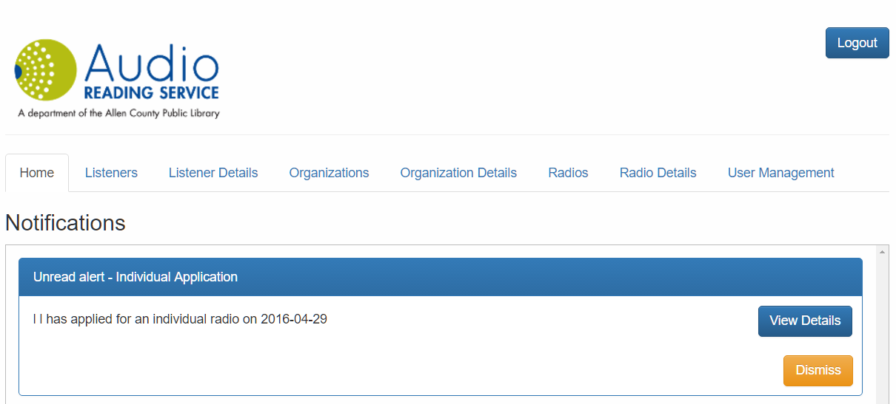

**Figure 1**

**The Listeners Tab**

The Listeners tab has several components to mention.

Near the top-right of the page, next to the red arrow in **Figure 2.1** are buttons to upload a file to import into the database and a button to export the currently displayed table to a .csv file.

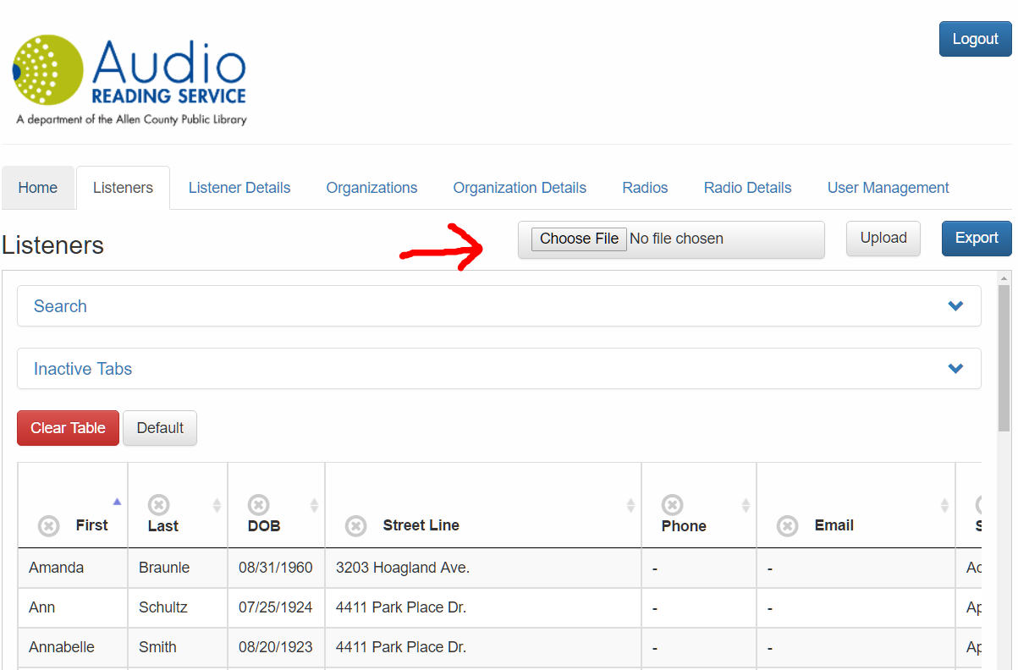

**Figure 2.1**

The Search collapsible shown in **Figure 2.2**  reveals a list of criteria that can be filled in to filter search terms. Clicking the ‘Search’ button in **Figure 2.3** will begin the search and display the results. In this case, a search was done on all listeners who have a first name with an ‘i’ and a last name that contains the letter ‘z’. Two results are returned in the table.

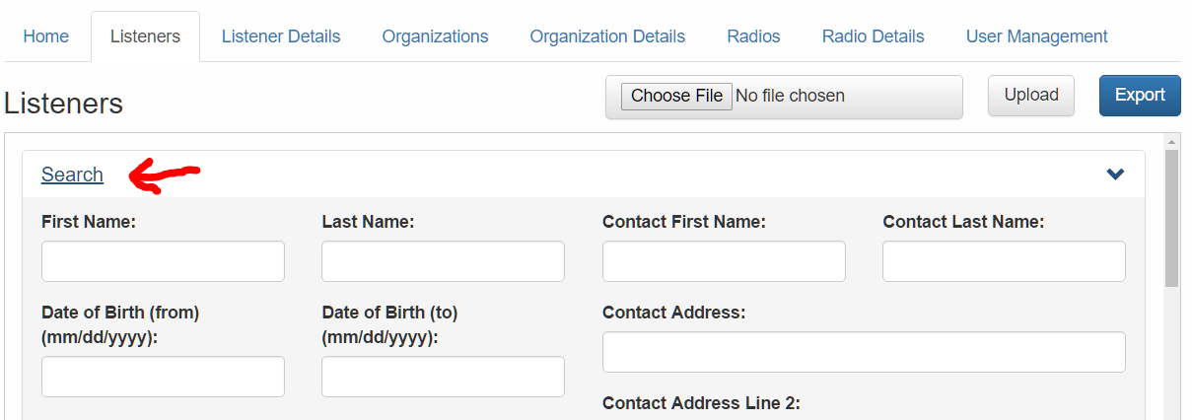

**Figure 2.2**

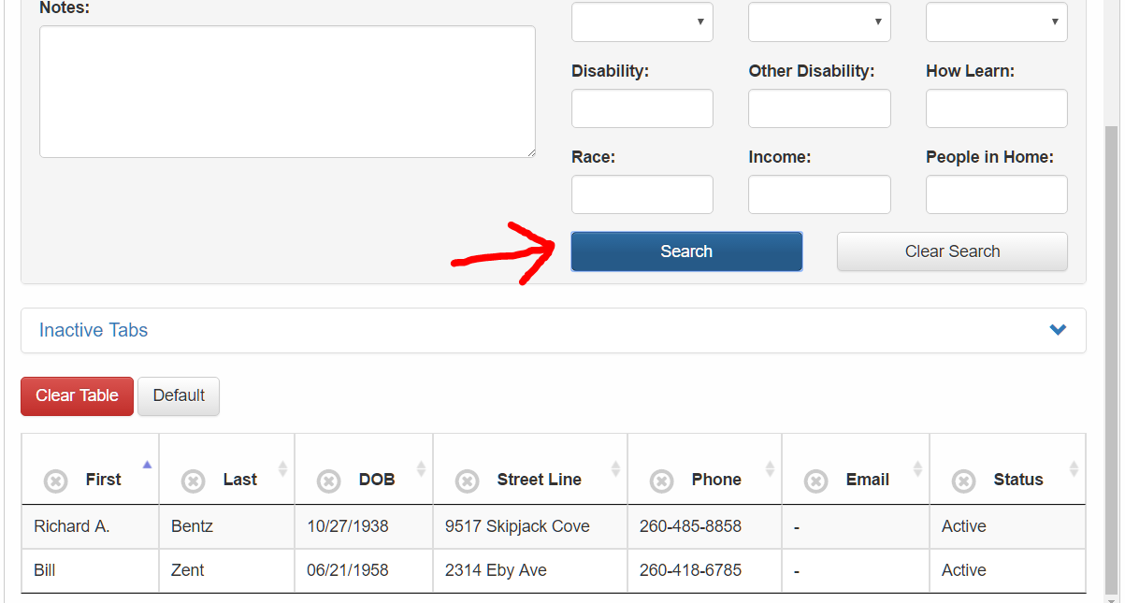

**Figure 2.3**

The Inactive Tabs collapsible shown in **Figure 2.4** displays a list of fields that are currently not displayed in the table. Clicking any of those buttons will remove that button from the Inactive Tabs and create a column in the table and fill it with the information corresponding to the button clicked. For example, if the ‘City’ button was clicked, the City button will be removed from the Inactive Tabs, a new column in the table with the header ‘City’ will be shown and the column will be filled with the cities of the corresponding listener.

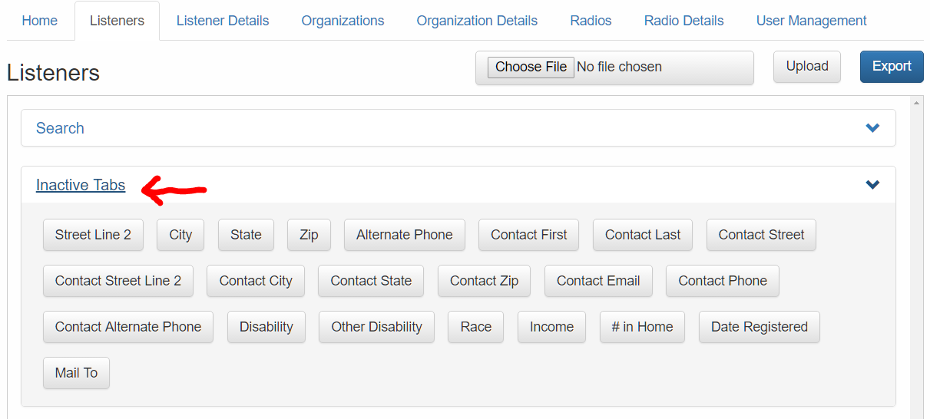

**Figure 2.4**

In the table headers you can see a button with an ‘X’ on the left and a button with arrows pointed either up or down in **Figure 2.5**. Clicking the ‘X’ button will remove that column from the displayed table and its button will appear in the Inactive Tabs list where it can be reactivated at will. The highlighted arrow (shown either up or down) shows the currently selected column and whether it is sorted in ascending or descending order. In this case, the First column is selected and it is sorted in ascending order.

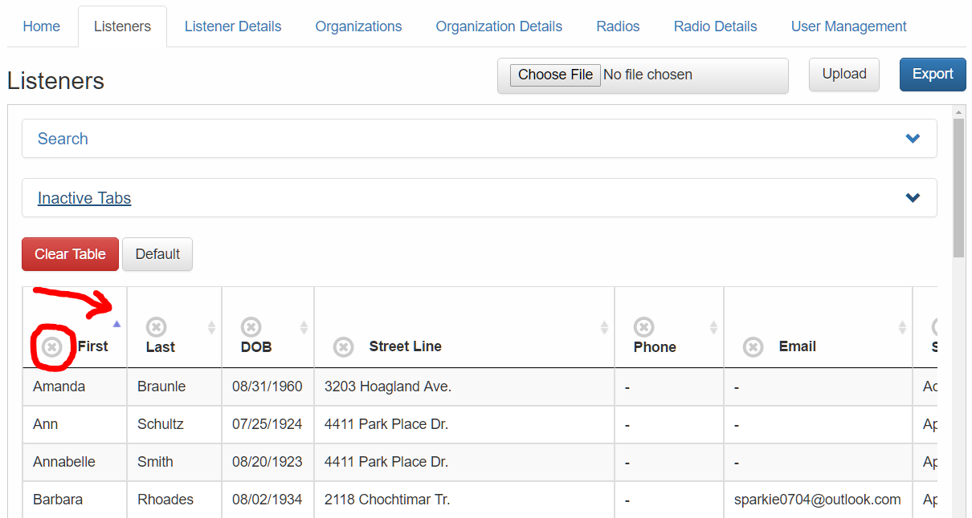

**Figure 2.5**

Any of the listeners can be clicked on to fill in the Listener Details tab with the selected information. For example, we will click on Ann Schultz.

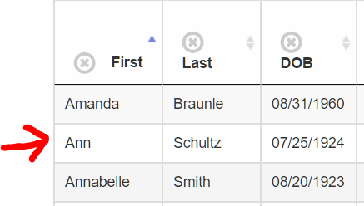**Figure 2.6**

**The Listener Details Tab**

The Listener Details tab, shown in **Figure 3.1,** contains a number of input boxes that can be filled in. When the tab is selected without prior clicking on a listener in the Listeners tab, the input boxes will appear empty. Likewise, clicking the New User button will clear any input boxes of information and allow a new listener to be added to the database manually once the Save New User button is clicked.

Also, **Figure 3.2** shows the Radios section which will list any radios that are currently checked out by the listener. The option to check in will be shown if there is such a radio.

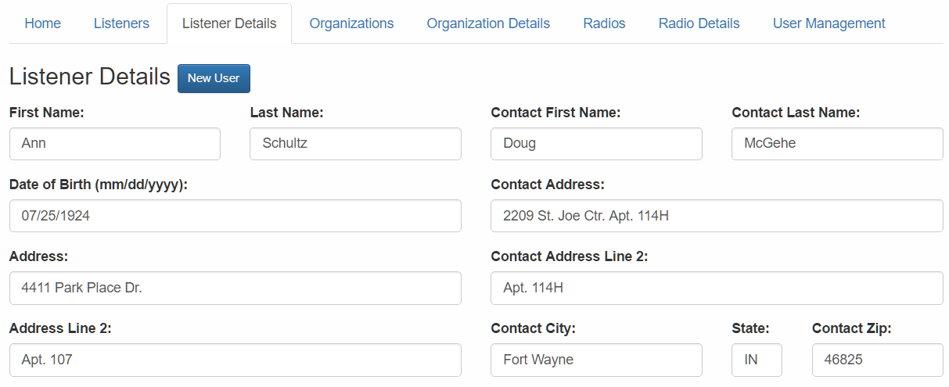

**Figure 3.1**

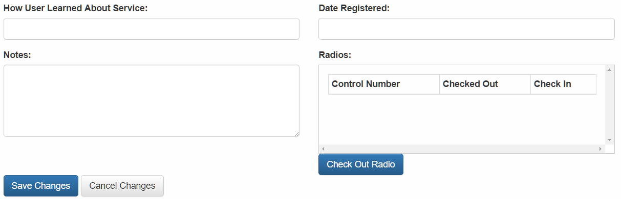

**Figure 3.2**

Checking out a radio for the current listener can be done by clicking the Check Out button. A popup window like the one shown in **Figure 3.3** will be shown allowing the Admin to enter the control number of the radio they plan to check out. If that radio is available, the check-out will commence. Otherwise, an error message will be displayed.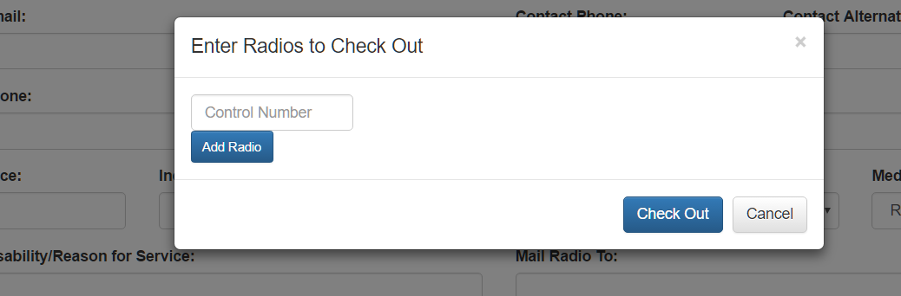

**Figure 3.3**

**The Organizations Tab**

The usage of the Organizations tab is similar to that of the Listeners tab.

**The Organization Details Tab**

The usage of the Organization Details tab is similar to that of the Listener Details tab.

**The Radios Tab**

The usage of the Radios tab is similar to the Listeners and Organizations tabs.

**The Radio Details Tab**

The usage of the Radio Details tab is similar to the Listener Details and Organization Details tabs. Additionally, **Figure 4.1** shows a Check Outs section for each radio which lists the history of who the radio was checked out to in the past, when it was checked out and when it was checked back in.

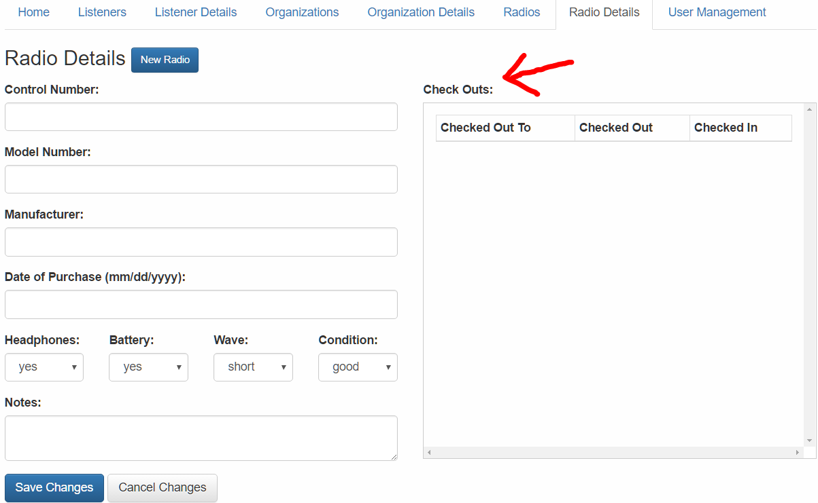 **Figure 4.1**

**The User Management Tab**

The User Management tab provides the ability to update the password of the currently logged in user and, if they are authorized, the ability to add new users who can log in to view the Admin interface.

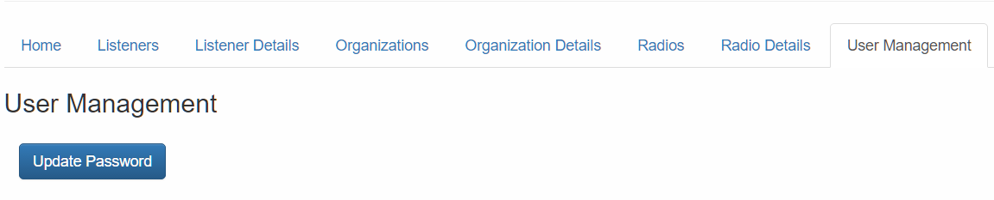

**Figure 5.1**

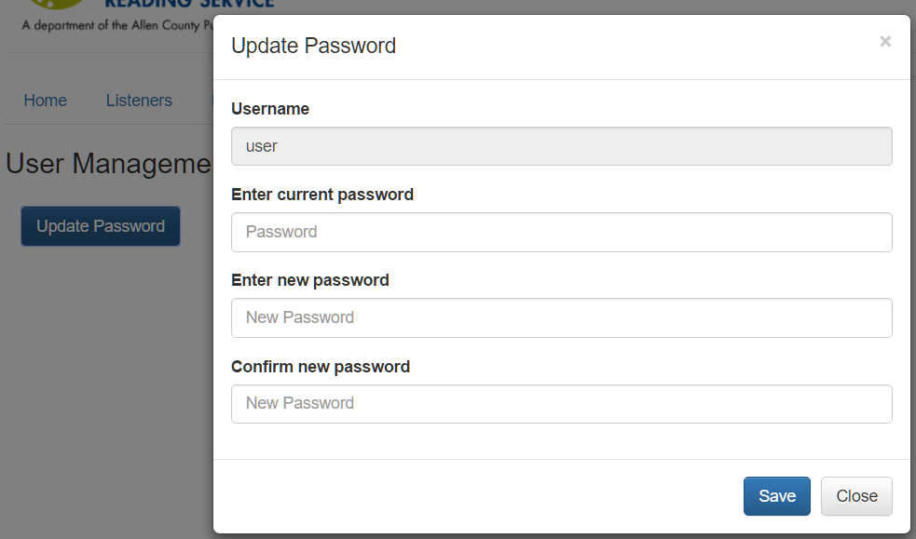

**Figure 5.2**